✴

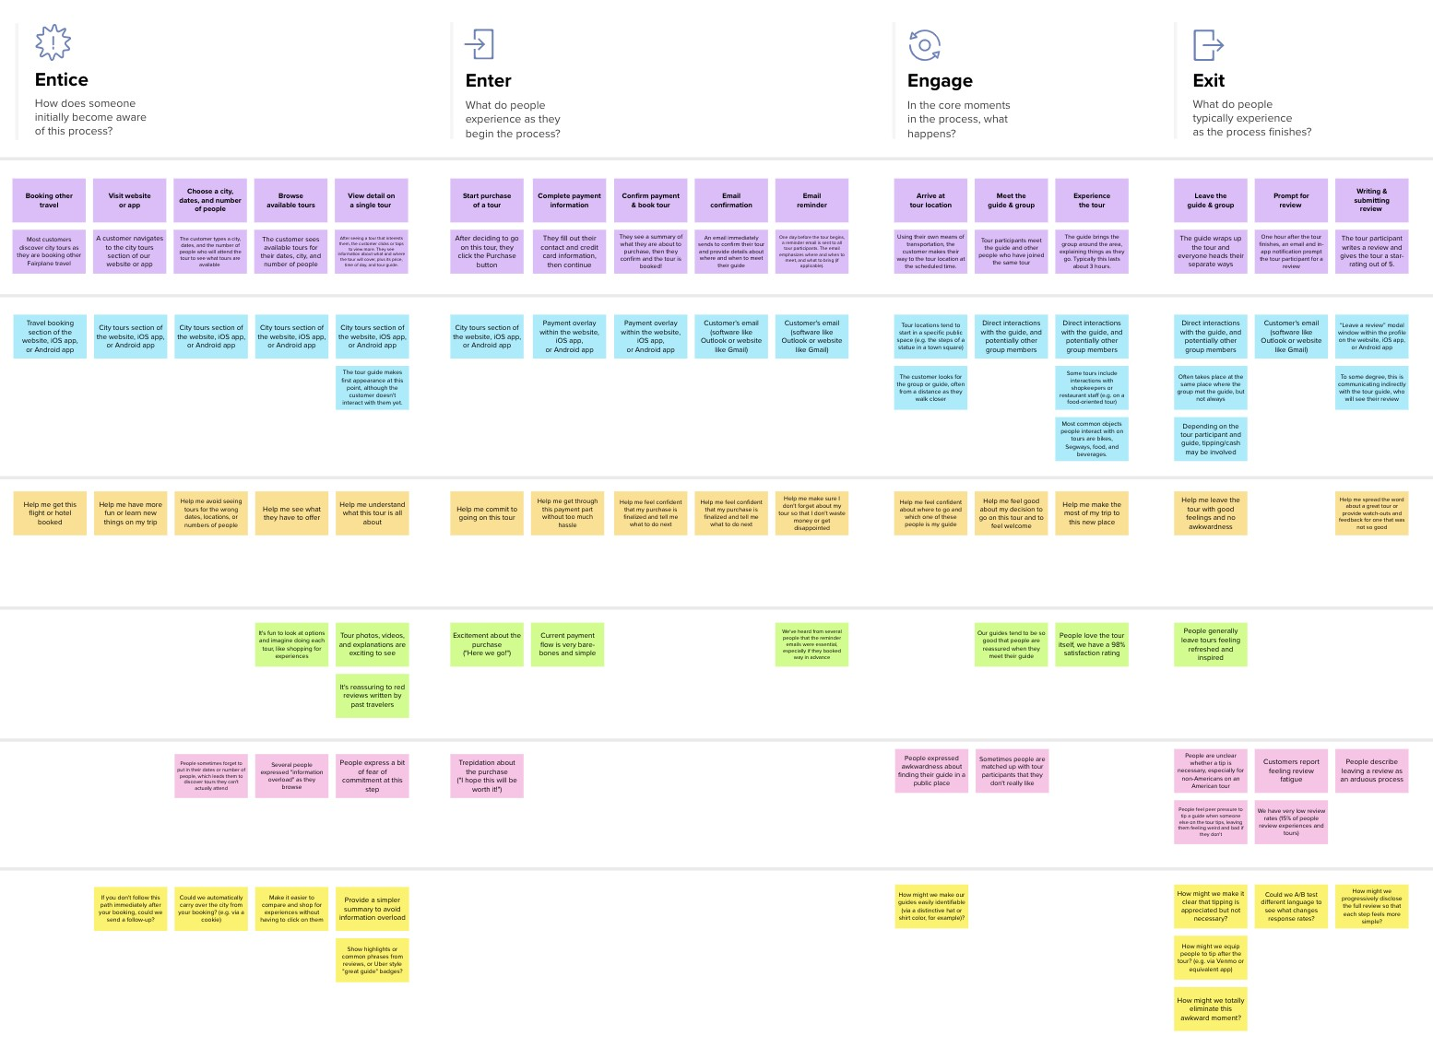

**Template**

**Document an existing experience**

**TIP**

As you add steps to the experience, move each these “Five Es” the left or right depending on the scenario you are documenting.

Narrow your focus to a specific scenario or process within an existing product or service. In the **Steps** row, document the step-by-step process someone typically experiences, then add detail to each of the other rows.

Customer experience journey map

|  |  |  |  |  |  |  |  |  |  |  |  |
| --- | --- | --- | --- | --- | --- | --- | --- | --- | --- | --- | --- |
| **SCENARIO**  **Browsing, booking, attending, and rating a local city tour** | **Entice**  How does someone initially become aware of this process? | | | **Enter**  What do people experience as they begin the process? | **Engage**  In the core moments in the process, what happens? | | | | | **Exit**  What do people typically experience  as the process finishes? | **Extend**  What happens after the experience is over? |
| **Steps**  What does the person (or group) typically experience? | **To gain knowledge**  **To know about the world around them** | **To know about economy** |  | **Customer**  **Facing Situation opens the**  **news**  **application**  **Between true and false** | **Checks notification** | **read news article** |  | **Opens news article** |  | **Desired Exit app Gained**  **content knowledge**  **newer investment** | **Newer Updated**  **techniques news**  **Adapt to true**  **environment information** |
| **Interactions**  What interactions do they have at each step along the way?  **People:** Who do they see or talk to? | **City tours section of the website, iOS app or android app** | **Connect news article from all the world**  **Deliver the information as fast as possible** |  | **Interact in visualize Checks phone to way see the article,**  **scrolling through all**  **other articles** | **Opens relevant news articles** |  | **Need to determine how you can monetize your app and essential features needed to make it successful** |  |  | **Retention with the news APIs can**  **app increases connect between**  **online news and**  **application** | **Manage content into categories that users can follow, browse and opt-1** |
| **Places:** Where are they?  **Things:** What digital touchpoints or physical objects would they use? |  |  |  | **Interactive database that tells new stories** |  | **Decides if the notification is interesting** |  | **Push notification can also be personalized** |  | **Show estimated reading time** |  |
| **Goals & motivations**  At each step, what is a person’s primary goal or motivation? (“Help me...” or “Help me avoid...”) | **Allow user to create and manage a profile** | **The most useful news app for any target audience will depend on the specific needs** |  | **97.99% no Have social**  **spamming integration** | **Filter fake news** |  | **Content more interactive** |  | **Customized data** | **A successful news Enables user to find**  **feedback interesting content**  **Increase the time that user spends on the app** | **Allowing user to find categories and individual articles related to interest**  **Manage content into categories** |
| **Positive moments**  What steps does a typical person find enjoyable, productive, fun, motivating, delightful, or exciting? | **Better information** | **Interesting facts** | **Satisfies Customer needs** | **Positive in the**  **stories Top trending news**  **Immediate knowledge of breaking news** | **Observe and witness true events** | **Information in visualize way** |  | **Behavior concerning digital news** | **The user like consuming reginal/ international news** | **Economic crisi gaining world**  **knowledge**  **Audio and video element** | **Daily lives Reports and**  **analytics**  **Real news with real time updates** |
| **Negative moments**  What steps does a typical person find frustrating, confusing, angering, costly, or time-consuming? | **Inappropriate about children** | **Information true or false** | **Influences on false news** | **Negativity**  **Agitate due to spammed notifications** | **Fake news** |  | **Overwhelmed because of too much information** |  |  | **Sometimes the content is too much**  **Normalizing than needed**  **violence** | **Debate Beat around the**  **bush** |
|  |  |  |  |  | **Frustration** |  | **Affecting the children knowledge** |  | **Financial frauds** |
| **Areas of opportunity**  How might we make each step better? What ideas do we have? What have others suggested? | **Focus on highly relevant content** | **Making a comeback as part of the broader industry pivot to reader** |  | **Behavior Delivering**  **customized stories** | **Competitor analysis** |  | **Create coverage reports** |  |  | **More data is required about behavior**  **Don't waste time collecting** | **Encourage users to Provide coverage**  **share content reports**  **across social media** |
|  | | | | | | | | | | |

Use this framework to better understand customer needs, motivations, and obstacles by illustrating a key scenario or process from start to finish.



When possible, use this map to document and summarize interviews and observations with real people rather than relying on your hunches or assumptions.



Created in partnership with



# 



[**Share template feedback**](https://muralco.typeform.com/to/CiqaHVat?typeform-source=app.mural.co)



**Need some inspiration?**

See a finished version of this template to kickstart your work.

[**Open example**](https://app.mural.co/template/f59f644b-b4b4-47b5-9ed6-3a8c71ceb612/896b31fe-5597-40ef-9b06-3811a1a45ace)